Do the following tutorial for the use of Passport
Note it uses a local version of mongo which must be running on your machine or else edit the app.js file to use a cloud version of mongo
Copy passport.zip from canvas and unzip it

In the root folder do
npm install
Now start the appliation
npm start

Register a new user and login as that user

To see the entries to the database start mongo from command line
mongo
use passport_local_mongoose_express6
db.accounts.find()
When I did this I got
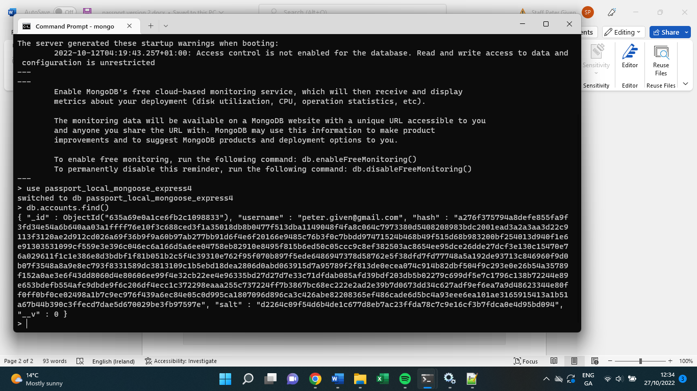

Note the Schema used for Account
const Account = new Schema({
username: String,
password: String
});

It includes a username and a password in the schema but the stored document stores a username, a hash and a salt instead
It also stores a version number and a Mongo ID

The application uses passportLocalMongoose which make it easier to work with passportLocal. You can see more here: https://github.com/saintedlama/passport-local-mongoose#hash-algorithm
Passport-Local Mongoose is a Mongoose plugin that simplifies building username and password login with Passport.
In your own project refactor the Register and Login forms to use passport. Use a get to /login to get the login form and a post to /login to use passport as shown above.

